Add Jira Ticket to Fresh Desk Ticket
Start From Fresh Desk Ticket
- Click on “Linked Tickets” and “Create a Tracker”
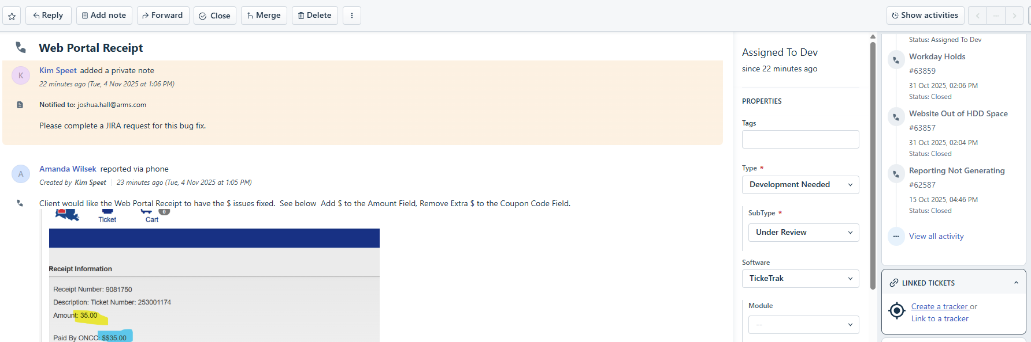

- Enter Ticket Information:
- Subject (Short Description)
- Type = Development Needed
- Sub Type = Under Review
- Software
- Module
- Status = Assigned to Dev
- Group = Tier 3
- Agent
- Full Description Details
- Click Create
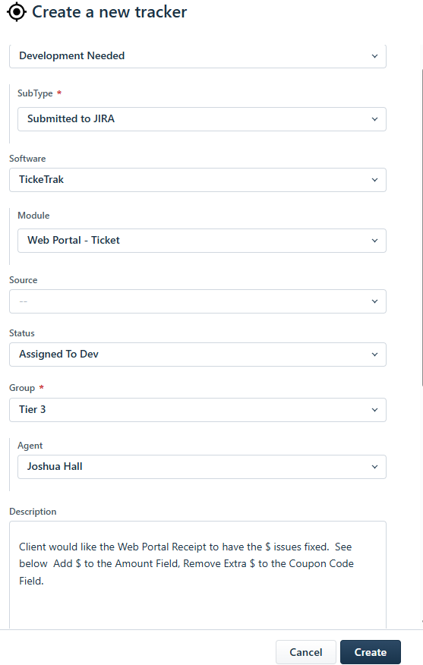
- Change the Status of the current ticket to “assigned to Dev”

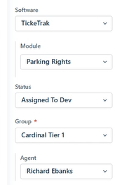

- Click on the linked ticket that was created under “linked tickets
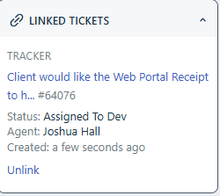

- Navigate to the “Atlassian JIR PLUS” tab and click “Create Issue”
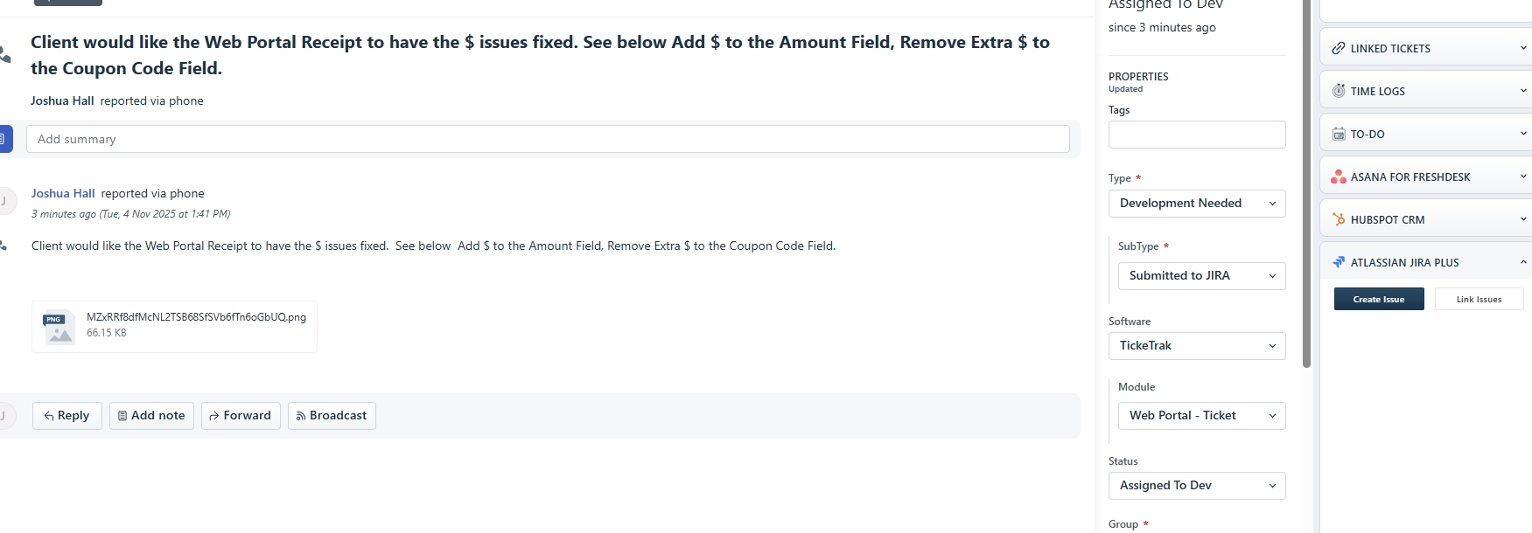

- Fill in the Jira information and click “Create Issue”
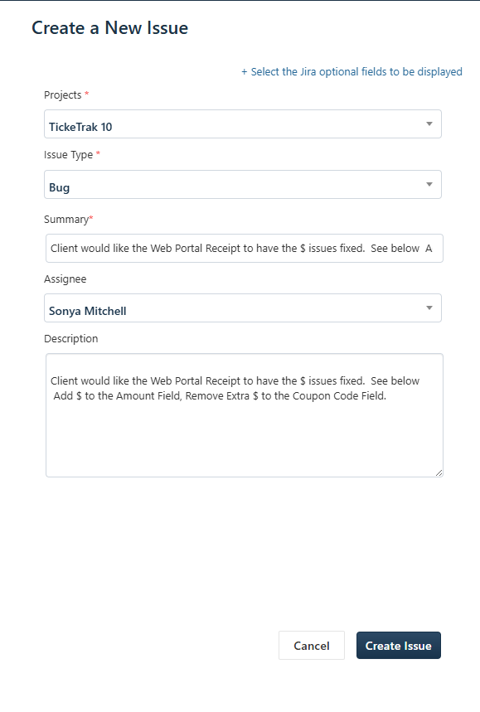

- On original ticket, add note of linked ticket and Jira and Sub Type to “Submitted to Jira”.

